Assignment #7: Rotational Motion

- You are looking at point A on the wheel. The wheel is rolling counterclockwise. It spins 8π radians in 2 seconds. Its radius is .3 m.
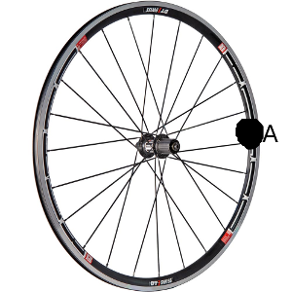
  - What is the arc-length (distance) that point a has traveled?

  - What is the rotational velocity of the wheel (speed and direction)?

  - What is the linear velocity of point A on the wheel?

  - What is the time it would take the wheel to make 10 complete rotations?

  - How far does point A travel during that time? (Arc-length)

- A washing machine starts at a complete rest. At t = 0 s, You start the machine, and it begins to spin. In 10 seconds, the basket of the machine has made 5 complete revolutions.
  - What is the angular acceleration of the basket?

  - What is the final angular velocity of the bucket -
    - in radians per second

    - in rotations per second

    - In degrees per second

- An electric fan is on “low”, spinning at a rate of 2.5 turns per second. The radius of the fan blades is 0.25 meters. You feel hot, and increase the speed of the fan to “high,” where the fan makes 5 revolutions per second. It takes 6 seconds for the fan to achieve its final speed.
  - What is the angular acceleration of the fan?

  - What is the linear acceleration of a point at the outer edge of the fan blade?

  - What is the final linear velocity of the same point?

  - How many rotations does the fan make during the time it is speeding up?

  - What is the distance traveled by a point on the edge of the fan?

  - What is the magnitude of the displacement vector of a point on the outside edge of the fan? (How far is the point from where it started?)

- A car is traveling 15 m/s, when he sees a deer on the road in front of him, and comes to a full stop in 4 seconds. The radius of its wheels are 20 cm.
  - What is the initial angular velocity of the wheels?

  - What is the angular acceleration of the wheels?

  - What is the angular position of the wheels when the car comes to a stop?

  - How far along the road does the car travel?

